|  |  |  |
| --- | --- | --- |
| **Experiment # 1** | | |
| Name: Dhrumil Burad | Roll No: E009 | **Date of Conduction:- 22 / 12 /2022** |
| **Class:- B. Tech (CSBS)-VI** | | **Division:- E** |

**Aim:**

Create a static web pages using HTML that has

1. Home Page (Your CV)

2. Registration page (Without using form)

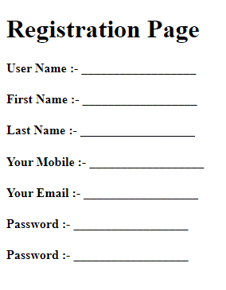

3. Contact Us page (To display address, mobile, email id etc)

**Question 1: - Home Page (Your CV)**

**Create a webpage to display your Curriculum vitae (CV) as per following format with all required entries.**

**MBA TECH/B. TECH. COMPUTER ENGINEERING**

**Name: - Your Name**

**OBJECTIVE:**

Write single line objective

**EDUCATION:**

|  |  |  |  |  |
| --- | --- | --- | --- | --- |
| **Degree** | **Institute** | **Board/University** | **CGPA/Percentage** | **Year** |
| B. Tech |  |  |  | Currently Pursuing |
| XII |  |  |  | 2019 |
| X |  |  |  | 2017 |

**Note: - if X & XII from same institute then use row span in institute column and If board is same for X & XII use row span in Board/University Column.**

**TECHNICAL SKILLS:**

|  |  |
| --- | --- |
| **Domain** | **Details** |
| Languages |  |
| Web Designing |  |
| Software |  |
| Database |  |
| Analytics |  |
| Operating Systems |  |

**KEY PROJECTS:**

|  |  |  |  |
| --- | --- | --- | --- |
| **Project Title** | **Duration** | **Platform Used** | **Brief Description** |
|  |  |  |  |
|  |  |  |  |
|  |  |  |  |

**TECHNICAL –PRESENTATION/WORKSHOPS/CERTIFICATION**

* Program 1
* Program 2

**TECHNICAL –WORK EXPERIENCE / INTERNSHIPS:**

1. Internship 1
2. Internship 2

**Prerequisites:-**

* NIL

**Outcomes:-**

* Student will know about web browser & how it interprets web pages.
* Students will know about how to execute HTML file
* Students will get idea about basic tags of HTML.
* Students will get idea about how to work with HTML list, table and images.

**Theory:-**

**What is HTML?**

HTML is a language for describing web pages. HTML stands for Hyper Text Markup Language. HTML is a markup language. A markup language is a set of markup tags. The tags describe document content. HTML documents contain HTML tags and plain text. HTML documents are also called web pages.

**HTML Tags**

HTML markup tags are usually called HTML tags. HTML tags are keywords (tag names) surrounded by angle brackets like <html>. HTML tags normally come in pairs like <p> and </p>. The first tag in a pair is the start tag, the second tag is the end tag. The end tag is written like the start tag, with a slash before the tag name. Start and end tags are also called opening tags and closing tags

**HTML Element Syntax**

An HTML element starts with a start tag / opening tag. An HTML element ends with an end tag / closing tag. The element content is everything between the start and the end tag. Some HTML elements have empty content. Empty elements are closed in the start tag. Most HTML elements can have attributes.

**HTML Attributes**

HTML elements can have attributes. Attributes provide additional information about an element. Attributes are always specified in the start tag. Attributes come in name/value pairs like: name="value".

**Its good practice to follow following html format:-**

<!DOCTYPE html>  
<html lang="en-us">  
<head>

<meta charset="utf-8">  
  <title> Title</title>  
</head>  
<body>  
  
</body>  
</html>

**HTML Tags:-**

**List**

* **Unordered List**

An unordered list starts with the **<ul>** tag. Each list item starts with the **<li>** tag.

**Example:**

<ul>  
  <li>Cricket</li>  
  <li>Tennis</li>  
  <li>Hockey</li>  
</ul>

* **Ordered List**

An ordered list starts with the **<ol>** tag. Each list item starts with the **<li>** tag.

**Example:**

<ol>  
  <li>Cricket</li>  
  <li>Tennis</li>  
  <li>Hockey</li>  
</ol>

* **Description List**

**<dl>** tag defines the description list

**<dt>** tag defines the term (name)

**<dd>** tag describes each term

**Example:**

<dl>  
  <dt>Static Web Page</dt>  
  <dd>- Do not change frequently</dd>  
  <dt>Dynamic Web Page</dt>  
  <dd>- Created at run time</dd>  
</dl>

* Nesting of list is also possible.

**Tables**

* An HTML table is defined with the **<table>** tag.
* Each table row is defined with the **<tr>** tag.
* A table header is defined with the **<th>** tag.
* By default, table headings are bold and centered.
* A table data/cell is defined with the **<td>** tag.
* **Example:**

<table >  
  <tr>  
    <th>Firstname</th>  
    <th>Lastname</th>   
    <th>Age</th>  
  </tr>  
  <tr>  
    <td>Sachin</td>  
    <td>Tendulkar</td>   
    <td>40</td>  
  </tr>  
  <tr>  
    <td>Rahul</td>  
    <td>Dravid</td>   
    <td>42</td>  
  </tr>  
</table>

**Cell that Span Many rows (Rowspan)**

<table style="width:100%">  
  <tr>  
    <th>Name:</th>  
    <td>RAM Rao</td>  
  </tr>  
  <tr>  
    <th rowspan="2">Mobile:</th>  
    <td>123456</td>  
  </tr>  
  <tr>  
    <td>654321</td>  
  </tr>  
</table>

**Images**

* Images help to make web page look attractive.
* We should always use images in jpg, gif or png, as browser supports these format.
* HTML images are defined with the **<img>** tag.
* Example

<img src="flower.jpg" alt="W3Schools.com" width="104" height="142">

* The compulsory attribute for <img> tag is **src** to specify URL of the image
  + **alt** stands for Alternate Text – If the browser is not supporting Images it display the value of ALT .
  + **height** and **width** specify the height and width of the image.
* Img also has following attributes
  + Hspace – specifies the amount of space to left and right of image.
  + Vspace – Specifies the amount of space to top and bottom of an image.
  + Border – Specifies border around an image.
  + Align – Defines the alignment of image.
* **Example:-**

<img src="home.jpg" alt="Hill Climbing" hspace=250 vspace=250 border=10 align="right">

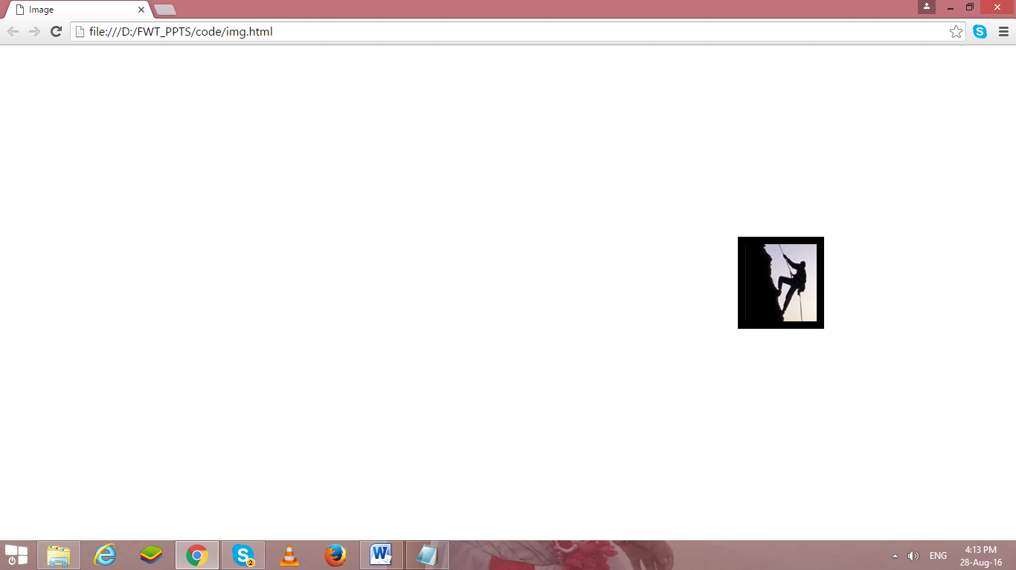

**Instructions:-**

1. Write html code in Note Pad & save with .html extension.
2. Execute using Web Browser.
3. Copy and Paste code as well as output (Print Scrn of output) in Part B

**PART B**

|  |  |  |
| --- | --- | --- |
| **Experiment # 1** | | |
| Name: Dhrumil Burad | Roll No: E009 | **Date of Conduction:- 22 / 12 /2022** |
| **Class:- B. Tech (CSBS)-VI** | | **Division:- E** |

# CODE:

## HOMEPAGE:

<!DOCTYPE html>

<html>

<head>

    <meta charset="utf-8">

    <meta http-equiv="X-UA-Compatible" content="IE=edge">

    <title>Practical 1</title>

    <meta name="description" content="">

    <meta name="viewport" content="width=device-width, initial-scale=1">

    <link rel="stylesheet" href="">

</head>

<body>

    <br>

    <br>

    <p align="center"><a href="./prac1homepage.html">MY CV</a><a> &nbsp &nbsp &nbsp </a> <a

            href="./prac1regispage.html">Registration

            page</a> <a> &nbsp &nbsp &nbsp </a> <a href="./prac1contact.html">Contact us</a>

    </p>

    <br>

    <br>

    <div align="center" id="logo">

        <img width="100px" src="./nmimslogo.png" alt="Logo">

        <br>

        <br>

        <strong> B.TECH. COMPUTER SCIENCE BUSINESS SYSTEMS</strong>

        <br>

    </div>

    <div>&nbsp&nbsp&nbsp&nbsp<strong>

            <h3> <u> Name:</u> </h3>

        </strong>Dhrumil Burad</div>

    <div>&nbsp&nbsp&nbsp&nbsp<strong>

            <h3 width="30px"> <u>Objective:</u> </h3>

        </strong> &nbspPursuing Bachelor of Technology (Hons.) in field of

        Computer Science with a specialization in Business Systems

    </div>

    <h3><u>Educational qualifications:</u></h3>

    <table border="2px" cellspacing="0" cellpadding="5px">

        <tr align="center">

            <th>Degree</th>

            <th>Institute</th>

            <th>Board/University</th>

            <th>CGPA/Percentage</th>

            <th colspan="2">Year</th>

        </tr>

        <tr align="center">

            <th>B.tech(Pursuing sem IV)</th>

            <td>MPSTME, Mumbai</td>

            <td>NMIMS University</td>

            <td>3.60/4</td>

            <td>2020</td>

            <td>2024</td>

        </tr>

        <tr align="center">

            <th>Class XII</th>

            <td rowspan="2">Podar International School, Ahmedabad</td>

            <td rowspan="2">CBSE</td>

            <td>88.4%</td>

            <td>2019</td>

            <td>2020</td>

        </tr>

        <tr align="center">

            <th>Class X</th>

            <td>81.2%</td>

            <td>2017</td>

            <td>2018</td>

        </tr>

    </table>

    <br>

    <h3><u>Technical Skills:</u></h3>

    <table border="2px" cellspacing="0" cellpadding="5px">

        <tr>

            <th>Domain</th>

            <th>Proficient in</th>

            <th>Familiar with</th>

        </tr>

        <tr>

            <th>Languages</th>

            <td>C++, HTML, CSS</td>

            <td>C, Java, Python,JavaScript</td>

        </tr>

        <tr>

            <th>Libraries and Frameworks</th>

            <td>Pandas, Numpy, Matplotlib</td>

            <td>Sklearn, seaborn</td>

        </tr>

        <tr>

            <th>Software</th>

            <td>Visual Studio Code, Code Blocks, NetBeans 8.0, <br>

                Adobe Illustrator, Canva, OBS studio, Camtasia, Jupyter<br>

                Notebooks, power director, FilmoraGo, Microsoft word,

                <br> Microsoft PowerPoint, Turbo C++, JFLAP, Pycharm

            </td>

            <td>Adobe Photoshop, Blender, TASM, <br>

                Star UML, Anaconda navigator, Microsoft Excel</td>

        </tr>

        <tr>

            <th>Concepts</th>

            <td>Business communication and value sciences,

                <br>Software engineering, Software Design UML

            </td>

            <td>Object Oriented Programming, Front end Web development<br>

                Data structures and algorithms</td>

        </tr>

    </table>

    <br>

    <h3><u>Key projects:</h3></u>

    <table border="2px" cellspacing="0" cellpadding="5px">

        <tr>

            <th>YEAR</th>

            <th>Project Title</th>

            <th>Software/ Tools/ Platforms</th>

            <th>Brief Description</th>

        </tr>

        <tr>

            <td>2021</td>

            <td>Online Shopping System</td>

            <td>Repl.it</td>

            <td>A group project wherein we made an online shopping system on repl.it using concepts of C++ and file

                handling.<br> It was a menu driven program where administrator had the options to update the item

                database and user <br>had options to view items, Add items to cart, view cart and payment</td>

        </tr>

        <tr>

            <td>2021</td>

            <td>The Streaming platform</td>

            <td>Visual studio code, Brave browser, Code Blocks</td>

            <td>In this project we made a dummy streaming platform using HTML, CSS and C++. The user could register or

                login <br>to the platform and then had options to choose a subscription and make payment. A SRS was made

                for the whole <br>project according to which code was implemented</td>

        </tr>

        <tr>

            <td>2022</td>

            <td>Multifunctional Pose Estimator Workout Guider </td>

            <td>Jupyter, Python, Collab,</td>

            <td>Developed a multifunctional pose estimator as a workout guide to track exercise repetitions. It uses

                human pose<br> estimation to track users' bodily motions. This, in turn, maintains track of exercise

                repetitions and detects incorrect <br>body positions while performing the exercise and also suggests how

                you should correct the form.</td>

        </tr>

    </table>

    <br>

    <h3><u>TECHNICAL -PRESENTATION/WORKSHOPS/CERTIFICATION</u></h3>

    <ul>

        <li> JavaScript, NodeJS and ReactJS, Ocufox Technologies in association with MPSTME, July 2022</li>

        <li> HTML Essential Training, LinkedIn Learning, May 2022</li>

        <li> Cold Calling: The First Seven Seconds, LinkedIn Learning, May 2022</li>

        <li> Learning to Say No with Confidence and Grace, LinkedIn Learning, January 2022</li>

        <li> edX Verified Certificate for Python Basics for Data Science, IBM, June 2021</li>

        <li> edX Verified Certificate for Preparing to Network in English, UWashingtonX, June 2021</li>

        <li> Udemy: Adobe Illustrator 2021 Ultimate Course, Learn Tech Plus, June 2021</li>

    </ul>

    <br>

    <h3><u>TECHNICAL -WORK EXPERIENCE / INTERNSHIPS:</u></h3>

    <ul>

        <li>Internshala <a> &nbsp &nbsp &nbsp &nbsp &nbsp &nbsp &nbsp &nbsp &nbsp &nbsp &nbsp &nbsp &nbsp </a> 3 months|

            Feb, 2021 to April, 2021| 2nd Sem

            <br> Student Partner

        </li>

        <li>Henry Harvin <a> &nbsp &nbsp &nbsp &nbsp &nbsp &nbsp &nbsp &nbsp &nbsp &nbsp &nbsp </a> 2

            months| April, 2021 to May, 2021 | 2nd Sem

            <br>Official Skill Ambassador

        </li>

    </ul>

</body>

</html>

## REGISTRATION PAGE:

<!DOCTYPE html>

<html>

<head>

    <title>Practical 1 Registration page</title>

    <meta name="description" content="">

</head>

<body align="Center">

    <br>

    <br>

    <p align="center"><a href="./prac1homepage.html">MY CV</a><a> &nbsp &nbsp &nbsp </a> <a

            href="./prac1regispage.html">Registration

            page</a> <a> &nbsp &nbsp

            &nbsp </a> <a href="./prac1contact.html">Contact us</a></p>

    <table border="2" cellspacing="0" cellpadding="0px" align="center">

        <tr align="left">

            <th>

                <h2> &nbsp Registration Page</h2>

            </th>

        </tr>

        <tr align="left">

            <td>

                <h4> &nbsp User Name: &nbsp __________________________________</h4>

            </td>

        </tr>

        <tr align="left">

            <td>

                <h4> &nbsp First Name: &nbsp __________________________________</h4>

            </td>

        </tr>

        <tr align="left">

            <td>

                <h4> &nbsp Last Name: &nbsp __________________________________</h4>

            </td>

        </tr>

        <tr align="left">

            <td>

                <h4> &nbsp Your Mobile: &nbsp __________________________________</h4>

            </td>

        </tr>

        <tr align="left">

            <td>

                <h4> &nbsp Your Email: &nbsp __________________________________</h4>

            </td>

        </tr>

        <tr align="left">

            <td>

                <h4>&nbsp Password: &nbsp __________________________________</h4>

            </td>

        </tr>

        <tr align="left">

            <td>

                <h4>&nbsp Re-enter Password: &nbsp ____________________________</h4>

            </td>

        </tr>

    </table>

</body>

</html>

## CONTACT PAGE:

<!DOCTYPE html>

<html>

<head>

    <meta charset="utf-8">

    <meta http-equiv="X-UA-Compatible" content="IE=edge">

    <title>Practical 1 Contact Page</title>

    <meta name="description" content="">

    <meta name="viewport" content="width=device-width, initial-scale=1">

    <link rel="stylesheet" href="">

</head>

<body>

    <br>

    <br>

    <p align="center">

        <a href="./prac1homepage.html">MY CV</a><a> &nbsp &nbsp &nbsp </a>

        <a href="./prac1regispage.html">Registration page</a><a> &nbsp &nbsp &nbsp </a>

        <a href="./prac1contact.html">Contact us</a>

    </p>

    <table border="0px" cellspacing="0" cellpadding="5px" align="center">

        <tr align="center">

            <td colspan="2">

                <h1>My Contact Details:</h1>

            </td>

        </tr>

        <tr align="left">

            <td>

                <h3><span>Name:</span></h3>

            </td>

            <td align="left">Dhrumil Burad</td>

        </tr>

        <tr align="left">

            <td>

                <h3><span>Phone number:</span></h3>

            </td>

            <td align="left">9898989898</td>

        </tr>

        <tr align="left">

            <td>

                <h3><span>Email.id:</span></h3>

            </td>

            <td align="left">dhrumilburad@gmail.com</td>

        </tr>

        <tr align="left">

            <td>

                <h3><span>Address:</span></h3>

            </td>

            <td align="left">NMIMS,MUMBAI</td>

        </tr>

        <tr align="left">

            <td>

                <h3><span>Social media handle:</span></h3>

            </td>

            <td align="left"><a href="#">LinkedIn</a></td>

        </tr>

    </table>

</body>

</html>

# Output

## HOMEPAGE

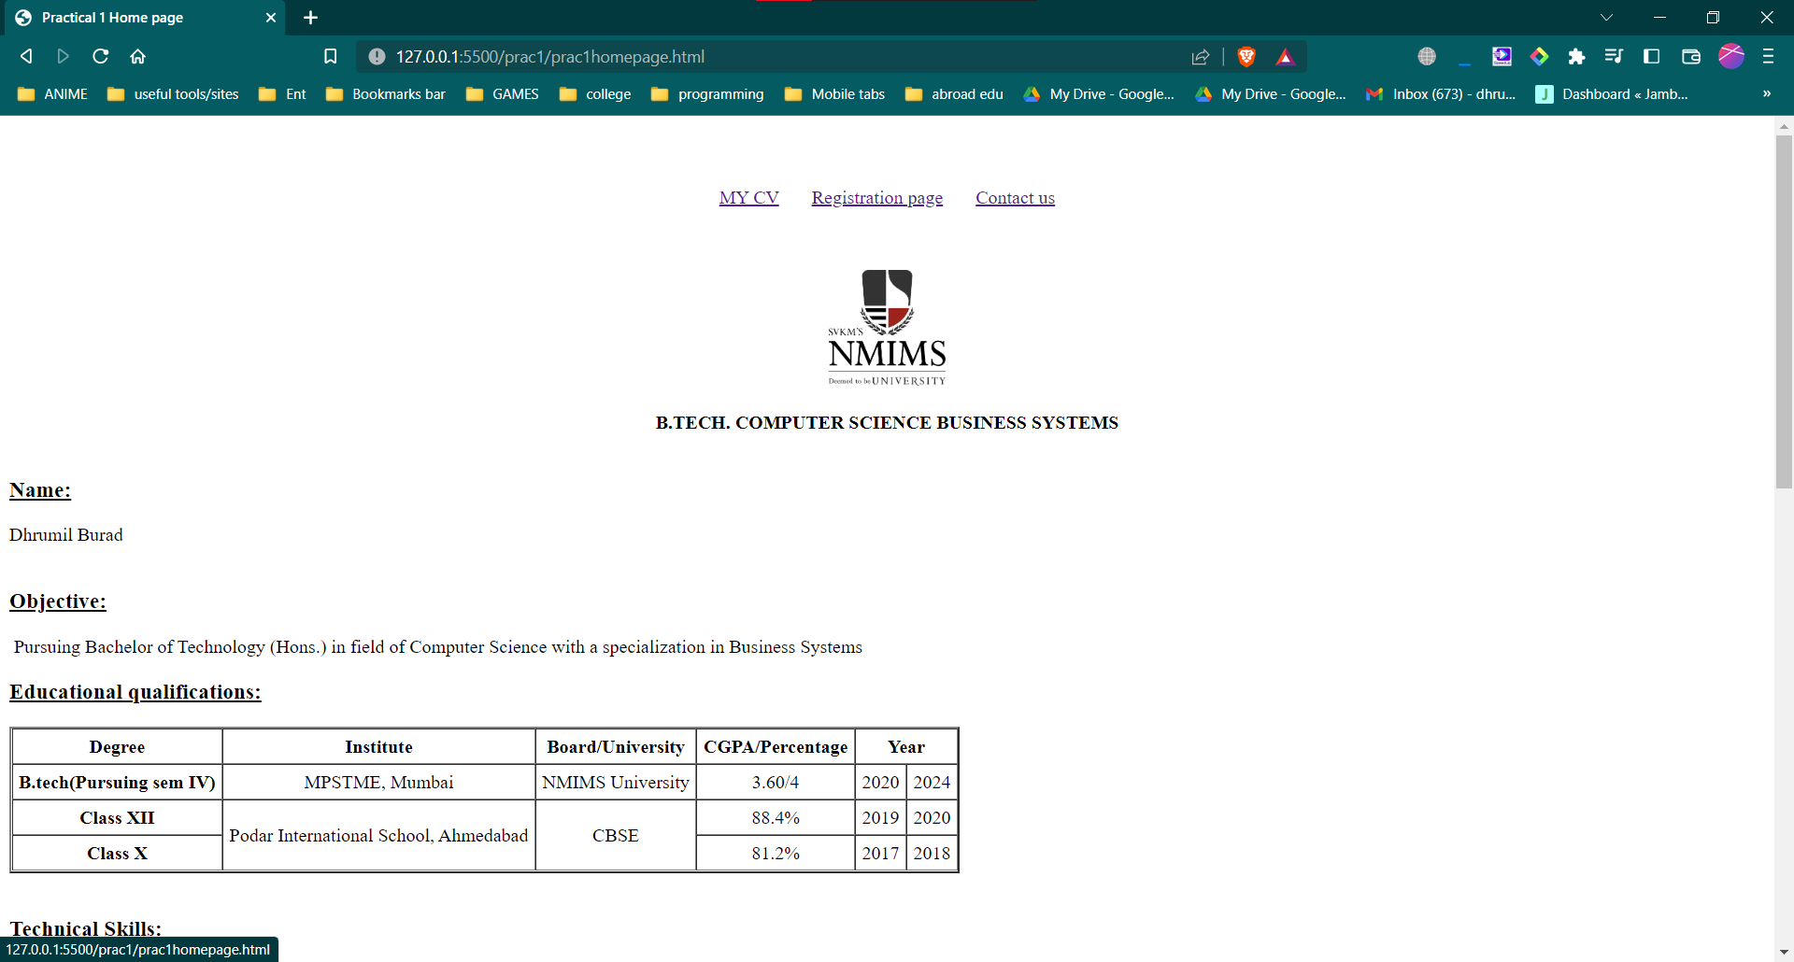

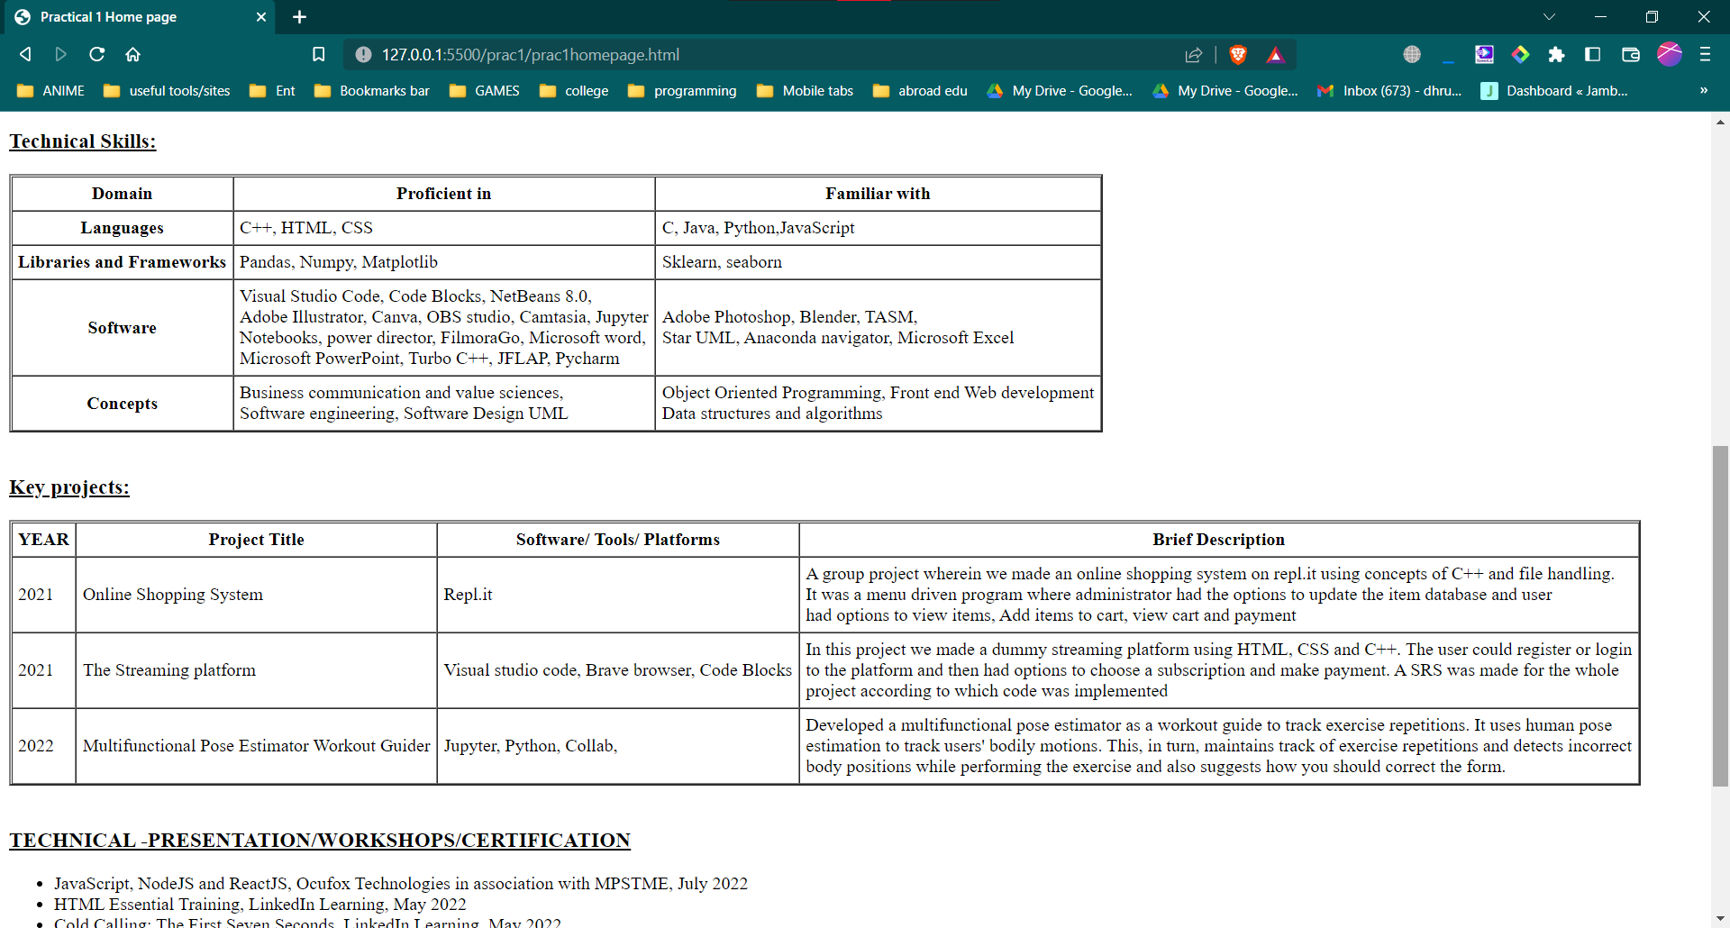

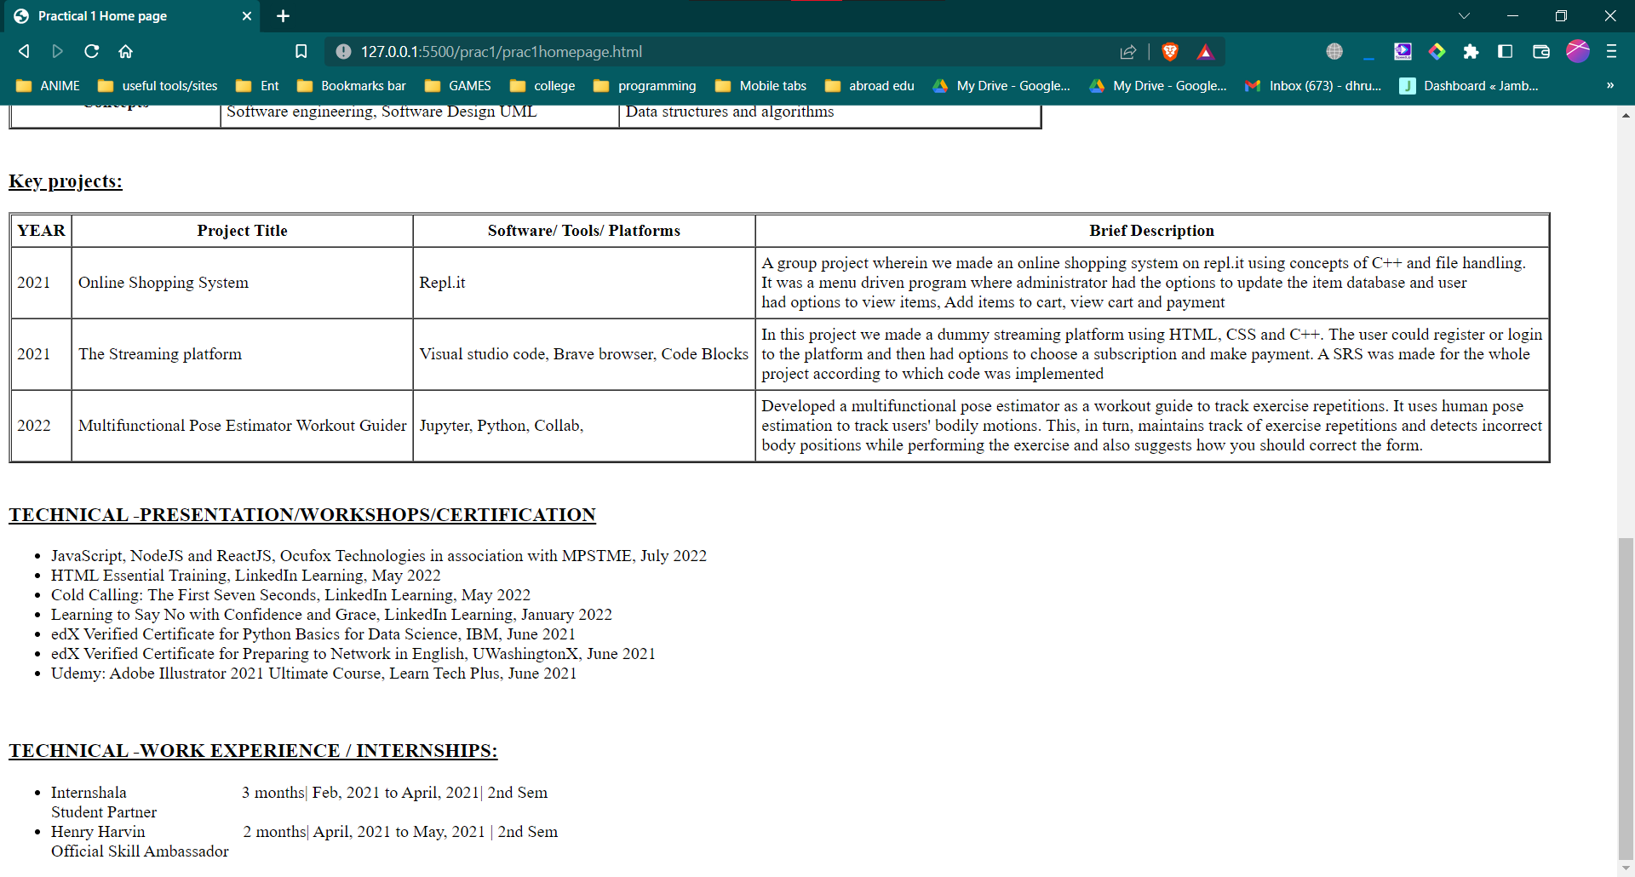

## REGISTRATION PAGE

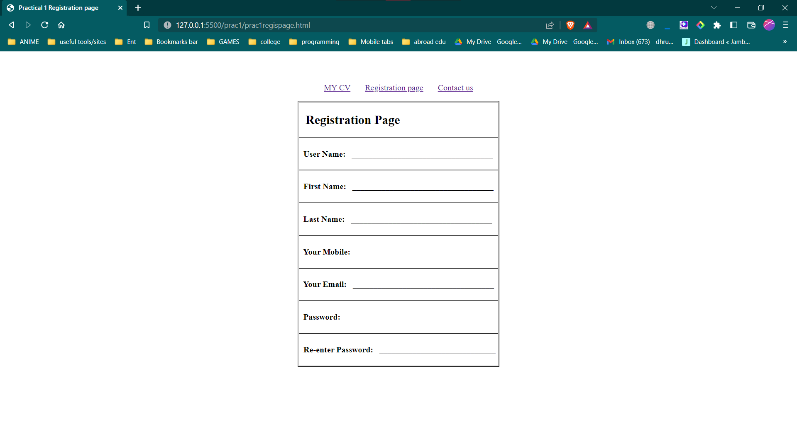

## CONTACT PAGE

